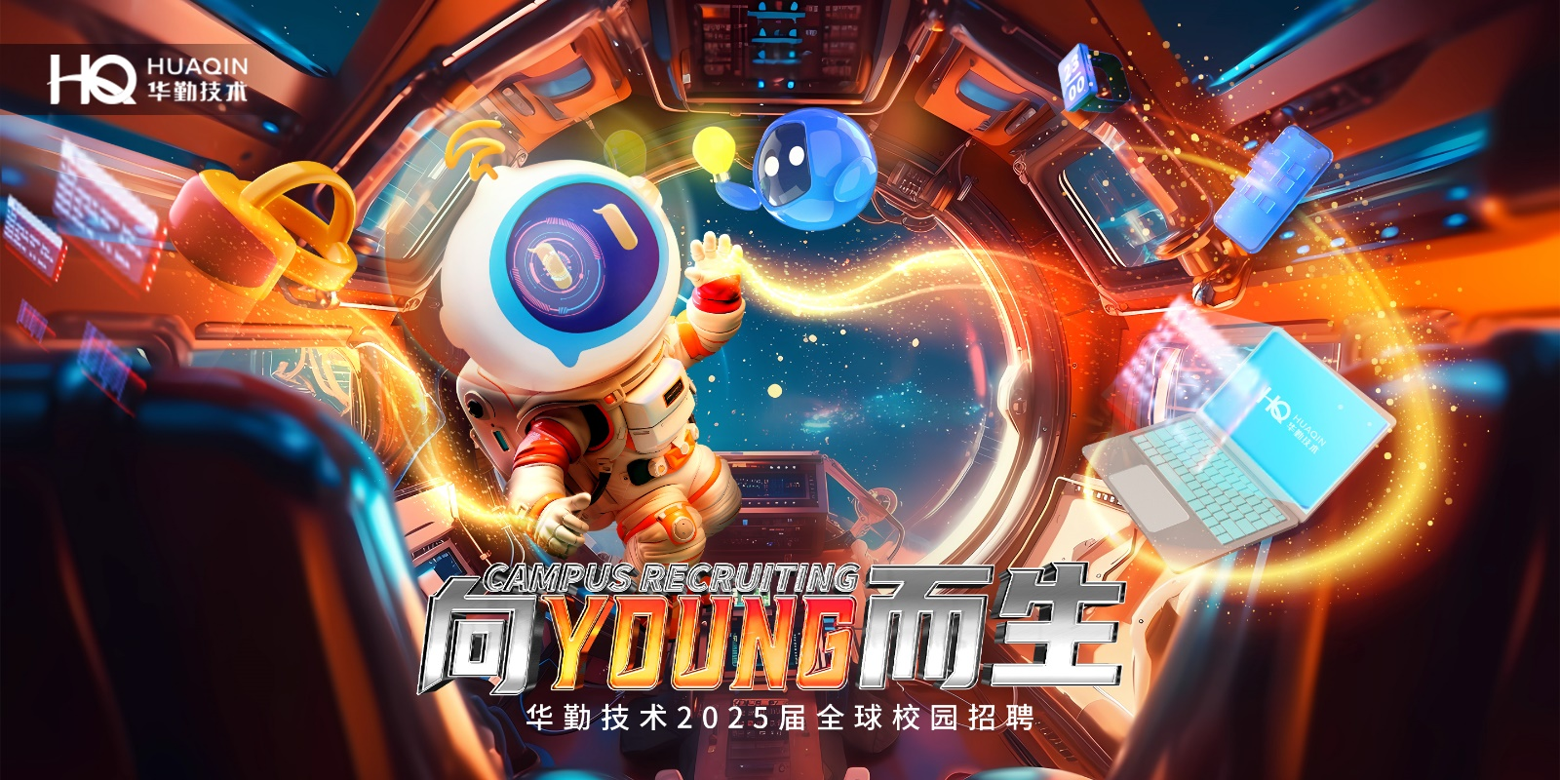

**华勤技术2025届全球校园招聘**

**Huaqin Technology 2025 Global Campus Recruitment**

技术未来，向YOUNG而生

**华勤技术 2025届校园招聘火热启动中！**

**Live Launch of Huaqin Technology 2025 Global Campus Recruitment**

**【企业介绍】**

Company Introduction

1. 华勤技术股份有限公司成立于2005年8月。作为一家全球智能产品平台型公司，主要从事智能产品的研发设计、生产制造和运营服务。服务于全球知名智能硬件品牌及互联网公司，在全球消费电子ODM领域拥有领先市场份额和产业链主地位。获2024年电子信息竞争力百强TOP20、2024中国《财富》中国科技50强、截至2024年6月发明专利授权1200++份、上海市创新型企业总部、国家知识产权示范企业、国家技术创新示范企业等荣誉。

Huaqin Technology Co., Ltd. was established in August 2005. As a global intelligent product platform company, it primarily engages in the research and development, design, production, manufacturing, and operational services of smart products. It serves globally renowned smart hardware brands and internet companies, holding a leading market share and a key position in the industrial chain within the global consumer electronics ODM field. The company has been recognized among the Top 20 of the 2024 Electronics Information Competitiveness Top 100, ranked among the 2024 Fortune China Top 50 Technology Companies, and has obtained over 1,200 invention patents as of June 2024. Additionally, it has been honored as Shanghai’s Headquarters of Innovative Enterprises, a National Intellectual Property Demonstration Enterprise, and a National Technological Innovation Demonstration Enterprise.

1. 全球员工近3万人，其中研发人员超1.2万人

We employ more than 30,000 team members worldwide, including more than 12,000 R&D staff.

1. 公司于2023年8月8日在上交所主板上市，股票代码：603296

The Company was listed on the main board of the Stock Exchange on August 8, 2023, stock code: 603296.

**【人性化福利】**

Humanized benefits

1. 丰富的薪资组成，五险一金+补充商业保险；

Generous salary composition, including five insurances and a pension with supplementary commercial insurance.

1. 餐补、交通补等各项补贴、创新奖、服务贡献奖等其他奖励；

Meal allowance, transportation allowance and other subsidies, milestone award, innovation award, service contribution award and other rewards.

1. 全面、系统、专业的培训；“活水计划”提供广阔的职业发展空间与提升机会；

Comprehensive, systematic and professional training; The "Living Water Program" provides a wide space for career development and promotion opportunities.

1. 丰富的员工关怀（如员工生日会、员工关爱基金、协会活动、公司旅游、团队拓展、年度体检等）；

Abundant staff care (staff birthday parties, staff care fund, association activities, company trips, team-building activities, annual physical examination, etc.).

1. 完善的晋升体系，导师及班主任带教政策，享受应届生快速成长通道。

Complete promotion system, mentor and class teacher coaching policy, a channel for rapid growth for fresh graduates.

**【校招安排】**

**School recruitment arragment**

**招聘对象：**

**Recruiting targets**

国内：2024年9月-2025年8月

Domestic：September 2024-August 2025

海外：2023年1月~2025年12月

Overseas: January 2023-December 2025

中国大陆院校以毕业证为准，港澳台及海外院校以学历学位认证书时间为准。

Global recruitment, with mainland China colleges and universities subject to providing graduation certificates, while Hong Kong, Macao, Taiwan and overseas colleges and universities subject to the time the degree certificates is issued.

**招聘岗位：**软件类、算法类、硬件类、结构类、测试类、IT类、大运营类、工程技术类、平台类、算法类等。

Positions: Software, algorithm, hardware, structure, testing, IT, operations, engineering technology, platform, algorithm, etc.

**工作城市：**上海、无锡、东莞、南昌、西安、天津、越南、墨西哥

Cities: Shanghai, Wuxi, Dongguan, Nanchang, Xi'an、Tianjing、Viet Nam, Mexico

**行程安排：**

Itinerary

1. 网申+测评（8月16日开始）、2~3轮面试（8月底陆续开始）、发放意向书（面试结束后一周），

offer发放与签约（意向书发放后滚动安排）

Online application and assessment (started by August 16), 2-3 rounds of interviews (started by end of August), Issuance of Letters of Intent (one week after interview) ，offer issue and contract signing （Rolling arrangements after Issuance of Letters of Intent）

1. 线下行程更新中，敬请关注~

Offline itinerary is being updated. Please stay tuned.

**简历投递：**

CV Submission

1. 校招官网：<https://jobs.huaqin.com>，了解更多职位信息，投递简历。

Please refer to the official website for school recruitment, https://jobs.huaqin.com, to learn more about job information and submit your CV.

1. 公众号：关注“华勤招聘”公众号，点击“校招网申”投递，并可了解最新动态。

Public account: Follow "HuaQin Recruitment," click on "school application" to submit your CV, and learn about the latest news.

1. 加入25届校招广西站交流QQ群，解锁更多投递渠道，获取最新校招资讯。

Join the 2025 school recruitment QQ group to unlock more submission channels and follow the latest school recruitment information.

（扫描二维码，开启网申） （华勤25届校招广西站交流群 群号: 854565032）

(Scan QR code, open online application) （Huaqin 2025 school recruitment exchange group）

**【注意事项】**

**Notes**

* 网申完毕后需在**5天内**完成**线上考试**+**线上测评**，非研发岗位仅需完成测评；

You need to complete the online exam and an online assessment within 5 days of completing the online application. Only the assessment is needed for non-R&D positions.

* 线下的招聘会行程，将第一时间公布在“华勤招聘”微信公众号

The itinerary of the offline job fair will be announced on the WeChat public account “Huajin Recruitment”

* 每位同学最多可以投递**二个**岗位类，每个岗位类允许投递三个工作地点，岗位及培养计划会根据投递志愿安排；Each student may apply for a maximum of two job categories, and for each category, they may select up to three work locations. Job assignments and training programs will be arranged based on the submitted preferences.

**【招聘岗位】**

**Recruitment Positions**

**硬件类**

**Hardware**

**硬件开发工程师、电源开发工程师、声学工程师、射频开发工程师**

Hardware development engineer、Power Supply Development Engineer, RF Development Engineer, Automation Equipment Development Engineer

**相关专业**

机械工程、电气工程、机电工程、信号处理、自动化、电子信息工程、电磁场与微波技术、力学、计算机科学、通信工程、信号处理、声学、物理学等。

**软件类**

**Software**

**驱动开发工程师（C语言、C++）、驱动开发工程师-BIOS/BSP/BMC、应用软件开发工程师（C++、JAVA）、影像开发工程师**

Driver development engineer (C language, C++), driver development engineer - BIOS/BSP/BMC, application software engineer (C++, JAVA), image processing development engineer

**相关专业**

电子信息工程、自动化、通信工程、通讯工程、计算机科学与技术、软件工程等。

**算法类**

**Algorithm**

**自动化算法工程师**

Automation Algorithm Engineer

**相关专业**

计算机科学与技术、自动化、应用数学、声学处理、数字信号处理、模式识别与智能系统、人工智能、物理学、数学与应用数学等。

**测试类**

**Test**

**软件测试工程师，硬件测试工程师**

Software Test Engineer, Hardware Test Engineer

**相关专业**

电子信息工程、自动化、通信工程、计算机科学与技术等。

**工程技术类**

**Engineering Technology**

**测试工程师、工业工程师、工艺工程师、经管工程师、计划工程师、设备工程师、体系工程师、物流工程师、项目经理、项目专员、 质量工程师、自动化工程师、厂务工程师、MES系统运维工程师、生产工程师、新产品导入工程师**Test Engineer, Industrial Engineer, Process Engineer, Management Engineer, Planning Engineer, Equipment Engineer, System Engineer, Logistics Engineer, Project Manager, Project Specialist, Quality Engineer, Automation Engineer, Factory Engineer, MES System Operation and Maintenance Engineer, Production Engineer, New Product Introduction Engineer

**相关专业**

管理科学、统计学、物流管理、自动化、机械工程、工业工程、通讯工程、电子信息工程、通信工程、计算机科学与技术、软件工程、信息管理、电力工程等。

**结构类**

**Structure**

**结构工程师，热设计工程师**

Structural development engineer，thermal design engineer

**相关专业**

自动化、机械工程、材料科学与工程、电气工程、工业设计、土木工程、热能工程、流体力学、工程热物理等。

**平台类**

**Platform**

**财务专员、人力资源专员、商务专员、市场专员、行政专员、ID设计工程师、技术销售专员、售前技术工程师**

Finance specialist, human resource specialist, Business specialist, marketing specialist, administrative specialist，ID Design Engineer, Technical Sales Specialist, Pre-sales Technical Engineer

**相关专业**

不限制专业。

**IT类**

**IT**

**IT开发工程师、IT数据开发工程师、IT网络安全工程师、IT需求分析工程师、IT运维工程师**

IT development engineer, IT Data Development Engineer , IT network security engineer, IT requirement analysis engineer, IT operation and maintenance engineer

**相关专业**

计算机科学、软件工程、信息技术、电子信息工程、通信工程、网络安全、网络工程等。

**大运营类**

**Operations**

**采购工程师、供应链计划工程师、供应商质量管理工程师、物流工程师、新产品导入工程师、质量工程师**

Procurement engineer, supply chain planning engineer, supplier quality management engineer, logistics engineer, New Product Introduction Engineer, quality engineer

**相关专业**

物流工程、物流管理、国际贸易、经济学、电子信息工程、电力工程、计算机科学与技术、机电工程、机械工程、材料科学与工程、自动化、通信工程、网络工程、软件工程等。

**联系人：任雪萌**

Liaison person: Ren Xue Meng

**联系方式：renxuemeng@huaqin.com**

Email： renxuemeng@huaqin.com