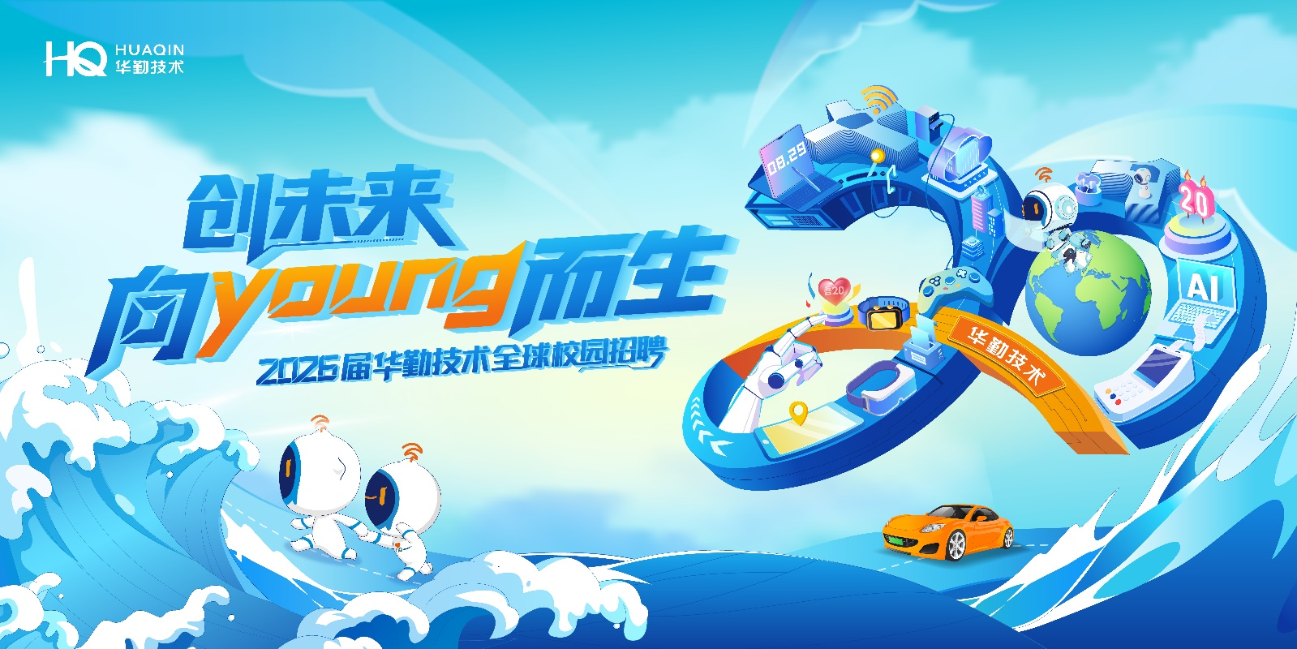

**华勤技术2026届全球校园招聘**

**Huaqin Technology 2026 Global Campus Recruitment**

创未来，向YOUNG而生

**华勤技术 2026届校园招聘火热启动中！**

**Live Launch of Huaqin Technology 20256Global Campus Recruitment**

**【企业介绍】**

Company Introduction

1. 华勤技术股份有限公司成立于2005年8月，总部位于上海。作为一家全球智能产品平台型公司，主要从事智能产品的研发设计、生产制造和运营服务。服务于全球知名智能硬件品牌及互联网公司，在全球消费电子ODM领域拥有领先市场份额和产业链主地位。公司荣获2024年度《财富》中国500强第231位、2024年度《财富》中国科技50强、2024年中国电子信息企业百强TOP 20、上海市创新型企业总部、国家知识产权示范企业、国家技术创新示范企业等荣誉。

Founded in 2005 and based in Shanghai, Huaqin Technology Co., Ltd. ("Huaqin Technology") is a world-leading enterprise specialized in smart products. As part of its mission to "Improve People's Communication and Life", Huaqin offers end-to-end product development, manufacturing, and operation of software, hardware, and systems to global tech companies. With a large customer base in more than 100 companies. With a large customer base in more than 100 countries and regions worldwide, Huaqin Technology provides global consumers with hundreds of millions of intelligent products including mobile phones, tablets, laptops, smart wearables, AIoT products, IDC products, and automotive electronics.

1. 全球员工近6万人，其中研发人员超1.6万人

We employ more than 60,000 team members worldwide, including more than 16,000 R&D staff.

1. 公司于2023年8月8日在上交所主板上市，股票代码：603296

The Company was listed on the main board of the Stock Exchange on August 8, 2023, stock code: 603296.

**【人性化福利】**

Humanized benefits

1. 丰富的薪资组成，五险一金+补充商业保险；

Competitive Compensation Package: Social insurance + housing fund + supplementary commercial insurance.

1. 餐补、交通补等各项补贴、创新奖、服务贡献奖等其他奖励；

Comprehensive Benefits: Meal allowances, transportation subsidies, innovation awards, service contribution awards, and more.

1. 全面、系统、专业的培训；“活水计划”提供广阔的职业发展空间与提升机会；

Career Development: Systematic training and development programs, along with our "Internal Mobility Plan" for career advancement opportunities.

1. 丰富的员工关怀（如员工生日会、员工关爱基金、协会活动、公司旅游、团队拓展、年度体检等）；

Employee Care Initiatives: Birthday celebrations, employee support funds, club activities, company trips, team-building events, and annual health check-ups.

1. 完善的晋升体系，导师及班主任带教政策，享受应届生快速成长通道。

Clear Career Progression: Structured promotion system with mentorship and buddy programs, plus fast-track growth paths for fresh graduates.

**【招聘岗位】**

**Recruitment Positions**

**1. 硬件类**

**Hardware Engineering**

硬件开发工程师、电源开发工程师、声学工程师、射频开发工程师

Hardware development engineer、Power Supply Development Engineer, RF Development Engineer, Automation Equipment Development Engineer

相关专业

机械工程、电气工程、机电工程、信号处理、自动化、电子信息工程、电磁场与微波技术、力学计算机科学、通信工程、信号处理、声学、物理学等。

Related majors

Mechanical Engineering, Electrical Engineering, Mechatronic Engineering, Signal Processing, Automation, Electronic Information Engineering, Electromagnetic Field and Microwave Technology, Mechanics and Computer Science, Communication Engineering, Signal Processing, Acoustics, Physics, etc.

**2. 结构类**

**Mechanical & Thermal Design**

结构工程师，热设计工程师

Structural development engineer，thermal design engineer

相关专业

自动化、机械工程、材料科学与工程、电气工程、工业设计、土木工程、热能工程、流体力学、工程热物理等。

Related majors

Automation, Mechanical Engineering, Materials Science and Engineering, Electrical Engineering, Industrial Design, Civil Engineering, Thermal Engineering, Fluid Mechanics, Engineering Thermophysics, etc.

**3. 软件类**

**Software Engineering**

驱动开发工程师（C语言、C++）、驱动开发工程师-BIOS/BSP/BMC、应用软件开发工程师（C++、JAVA）、影像开发工程师

Driver development engineer (C language, C++), driver development engineer - BIOS/BSP/BMC, application software engineer (C++, JAVA), image processing development engineer

相关专业

电子信息工程、自动化、通信工程、通讯工程、计算机科学与技术、软件工程等。

Related majors

Electronic Information Engineering, Automation, Communication Engineering, Communication Engineering, Computer Science and Technology, Software Engineering, etc.

**4. 测试类**

**Testing & Quality Assurance**

软件测试工程师，硬件测试工程师

Software Test Engineer, Hardware Test Engineer

相关专业

电子信息工程、自动化、通信工程、计算机科学与技术等。

Related majors

Electronic Information Engineering, Automation, Communication Engineering, Computer Science and Technology, etc.

**5. 算法类**

**Algorithm & AI**

自动化算法工程师

Automation Algorithm Engineer

相关专业

计算机科学与技术、自动化、应用数学、声学处理、数字信号处理、模式识别与智能系统、人工智能、物理学、数学与应用数学等。

Related majors

Computer Science and Technology, Automation, Applied Mathematics, Acoustic Processing, Digital Signal Processing, Pattern Recognition and Intelligent Systems, Artificial Intelligence, Physics, Mathematics and Applied Mathematics, etc.

**6. 工程技术类**

**Manufacturing & Industrial Engineering**

测试工程师、工业工程师、工艺工程师、经管工程师、计划工程师、设备工程师、体系工程师、物流工程师、项目经理、项目专员、质量工程师、自动化工程师、厂务工程师、MES系统运维工程师、生产工程师、新产品导入工程师Test Engineer, Industrial Engineer, Process Engineer, Management Engineer, Planning Engineer, Equipment Engineer, System Engineer, Logistics Engineer, Project Manager, Project Specialist, Quality Engineer, Automation Engineer, Factory Engineer, MES System Operation and Maintenance Engineer, Production Engineer, New Product Introduction Engineer

相关专业

管理科学、统计学、物流管理、自动化、机械工程、工业工程、通讯工程、电子信息工程、通信工程、计算机科学与技术、软件工程、信息管理、电力工程等。

Related majors

Management Science, Statistics, Logistics Management, Automation, Mechanical Engineering, Industrial Engineering, Communication Engineering, Electronic Information Engineering, Communication Engineering, Computer Science and Technology, Software Engineering, Information Management, Electric Power Engineering, etc.

**7. IT类**

**IT & Cybersecurity**

IT开发工程师、IT数据开发工程师、IT网络安全工程师、IT需求分析工程师、IT运维工程师

IT development engineer, IT Data Development Engineer , IT network security engineer, IT requirement analysis engineer, IT operation and maintenance engineer

相关专业

计算机科学、软件工程、信息技术、电子信息工程、通信工程、网络安全、网络工程等。

Related majors

Computer Science, Software Engineering, Information Technology, Electronic Information Engineering, Communication Engineering, Network Security, Network Engineering, etc.

**8. 大运营类**

**Operations & Supply Chain**

采购工程师、供应链计划工程师、供应商质量管理工程师、物流工程师、新产品导入工程师、质量工程师

Procurement engineer, supply chain planning engineer, supplier quality management engineer, logistics engineer, New Product Introduction Engineer, quality engineer

相关专业

物流工程、物流管理、国际贸易、经济学、电子信息工程、电力工程、计算机科学与技术、机电工程、机械工程、材料科学与工程、自动化、通信工程、网络工程、软件工程、工业工程、运营管理、供应链管理、采购与供应管理、质量管理、数据科学与大数据技术、信息管理与信息系统、工商管理、应用统计学、电气工程及其自动化、系统工程、电子商务

Related majors

Logistics Engineering、Logistics Management、International Trade、Economics、Electronic Information Engineering、Electric Power Engineering、Computer Science and Technology、Mechanical and Electrical Engineering、Mechanical Engineering、Materials Science and Engineering、Automation、Communication Engineering、Network Engineering、Software Engineering、Industrial Engineering、Operations Management、Supply Chain Management、Procurement and Supply Management、Quality Management、Data Science and Big Data Technology、Information Management and Information Systems、Business Administration、Applied Statistics、Electrical Engineering and Automation、Systems Engineering、E-commerce etc.

**9. 平台类**

**Corporate Functions**

财务专员、人力资源专员、商务专员、市场专员、行政专员、ID设计工程师、技术销售专员、售前技术工程师

Finance specialist, human resource specialist, Business specialist, marketing specialist, administrative specialist，ID Design Engineer, Technical Sales Specialist, Pre-sales Technical Engineer

相关专业

不限制专业。

Related majors

There is no restriction on majors.

**【校招安排】**

**Campus recruitment arragment**

**招聘对象：**

**Recruiting targets**

国内：2025年9月-2026年8月

海外：2024年1月~2026年12月

中国大陆院校以毕业证为准，港澳台及海外院校以学历学位认证书时间为准。

Bachelor’s/Master’s/Ph.D.

Graduation Window: Jan 2024 – Dec 2026

The certification date issued by China's Ministry of Education for academic credentials is definitive.

**招聘岗位：**软件类、算法类、硬件类、结构类、测试类、IT类、大运营类、工程技术类、平台类、算法类等。

Positions: Hardware Engineering，Software Development，Testing & Quality Assurance，Mechanical & Thermal Design，Algorithms & AI，Corporate Functions，Operations & Supply Chain，IT & Cybersecurity，Manufacturing & Industrial Engineerin

**工作城市：**上海、无锡、东莞、南昌、西安、天津、武汉、重庆、河源、北京、越南、墨西哥、印度

China: Shanghai, Wuxi, Dongguan, Nanchang, Xi'an, Tianjin, Wuhan, Chongqing, Heyuan, Beijing

International: Vietnam, Mexico, India

**行程安排：**

Itinerary

1. 网申+测评（8月18日开始）、2~3轮面试（8月底陆续开始）、发放意向书（面试结束后一周），

offer发放与签约（意向书发放后滚动安排）

Online application and assessment (started by August 18), 2-3 rounds of interviews (started by end of August), Issuance of Letters of Intent (one week after interview) ，offer issue and contract signing （Rolling arrangements after Issuance of Letters of Intent）

1. 线下行程更新中，敬请关注~

Offline itinerary is being updated. Please stay tuned.

**简历投递：**

CV Submission

1. 校招官网：<https://jobs.huaqin.com>，了解更多职位信息，投递简历。

Please refer to the official website for school recruitment, https://jobs.huaqin.com, to learn more about job information and submit your CV.

1. 公众号：关注“华勤招聘”公众号，点击“校招网申”投递，并可了解最新动态。

Public account: Follow "HuaQin Recruitment," click on "school application" to submit your CV, and learn about the latest news.



（扫描二维码，开启网申）

(Scan QR code to application)

**【注意事项】**

**Notes**

* 网申完毕后需在**5天内**完成**线上考试**+**线上测评**，非研发岗位仅需完成测评；

You need to complete the online exam and an online assessment within 5 days of completing the online application. Only the assessment is needed for non-R&D positions.

* 线下的招聘会行程，将第一时间公布在“华勤招聘”微信公众号

The itinerary of the offline job fair will be announced on the WeChat public account “Huajin Recruitment”

* 每位同学最多可以投递**两个**岗位，每个岗位类允许投递三个工作地点，岗位及培养计划会根据投递志愿安排；Each student may apply for a maximum of two job categories, and for each category, they may select up to three work locations. Job assignments and training programs will be arranged based on the submitted preferences.

**联系人：华勤技术校招组**

**联系方式：campus@huaqin.com**